**MY400 – Fundamentals of Social Science Research Design:**

**Lectures & Seminars**

**Lecture: Week 1 –**

**3 sections to module:**

1. **Learning how to design research**
   1. **Introduction to principles of designing research**
      1. **Key concepts**
      2. **Criteria for good research**
      3. **Good practice**
      4. **Types of choices we will have to make**
         1. **Theory and data**
         2. **Desk-based research**
         3. **Operationalisation, sampling and measurement**
         4. **Ethics, reflexivity, writing**
2. **Research designs**
   1. **Overview of different types of research design**
      1. **Intro to commonly used designs**
      2. **Qual/Quant/Mixed-methdos**
         1. **Case study and comparison**
         2. **Inference & causality**
         3. **Experiments and observations**
         4. **Immersive methods and collecting data**
         5. **Multi-method and mixed-method research designs**
3. **Learn how to design and write a research proposal autonomously**
   1. **Unguided work**
      1. **Assessment period**
      2. **No feedback or help.**
         1. **Objective of assessment is for you to:**
            1. **Demonstrate the research design principles that you have learnt throughout the module**
            2. **A milestone on capstone project journey.**

**Each week**

* **COMPULSORY SEMINAR READINGS**
* **Seminar Preparation document informs you what needs to be prepared**

**Methodological Pluralism**

* Multiple valid approaches to producing knowledge in social science
* Skilled scholars can critically read and use diverse sources
* Different research designs imply different trade-offs
* Designing a research project autonomously can be challenging…
  1. It implies making a lot of decisions
  2. There is rarely a whole research design out there than perfectly fits our specific project, which requires creativity.
* … but learning guidelines and criteria of good research practice are here to help us make these decisions and improve the quality of our work.

Research Design is about:

* Familiarizing ourselves with what other people have done
* Making informed and conscious decisions at each stage of our research project
* Being capable of justifying these choices to our readers in a convincing way.

**Need to expand on research proposal from MY400 & add components if I want to use in capstone project.**

**MY400 will not provide:**

* The field of inquiry, research topic or theoretical motivation
* The research question
* The data

**MY400 will provide:**

* Exposure to a wide range of strategies for doing social science research, their relative strengths and limitations, and the tradeoffs involved with different approaches.
* Language to communicate nd justify research strategy
* An opportunity to spend time developing a RP and getting feedback.

**Assessment**

* **Formative**
  1. Revision Meme
     + Create a revision meme focusing on a principle of research design to remember, and post it on the “Meme your research design blog” (On Moodle)
       - Objective: revise the first part of the module and collectively create a meme database to recall important principles of research design/criteria of good research.
  2. Project outline:
     + A synthetic project outline (do not exceed 2 pages)
       - Objectives
         * 3 sections - Introduce research topic, positioning in the literature and research question.
         * Practice ‘coherence’: The research question should be logically motivated by the choice of research topic and literature introduced.
         * Put some choices in writing to avoid further postponing making decisions.
         * Deadline is pedagogical, no extensions on the formative assignment as this defeats the purpose. It is better to submit something incomplete and receive feedback on it rather than further postponing making decisions.
  3. Check the document “Things to read before your formative assignment” on Moodle.
* **Summative** 
  1. 3000-word research proposal
     + Objectives of the modules is to learn skills and criteria of good research design
     + Objective of the assignment is to demonstrate I’ve learnt
  2. Check “Things to read before starting your summative assignment.”

**Audrey Alejandro, “How to construct and formulate research questions”**

**AA, “How to identify a research topic”**

**How to identify a research topic**

* Starting point 1: Something that interests you in the socio-political world.
* Starting point 2: Analytical frameworks (theories and concepts) that make sense to you and that you would like to use.
* Starting point 3: There is a piece of research that inspires you and that you would like to emulate.

Do you already have a broad (idea) of research topic?

If so, where does it come from (e.g. one of the three ‘starting points’)?

Criteria to refine and select research topic

* Module/programme expectations.
* Skill set.
* Personal interest.
* Feasibility.
* Planned trajectory.

Can I change my topic?

* It is a normal part of the research process for the research topic to evolve
* An evolving research topic vs. changing research topic

Research topic does not equal research question.

* Once you have a topic, clarifying the purpose(s) of your research can be crucial to developing research questions
* Different research questions can focus on the same research topic

**Constructing a good research question**

* RQs can prvide the key to planning and carrying out a successful research project (Robson & McCartan 2016:59)
* They help to:
  1. Define your project (summarise focus)
  2. Set boundaries (demarcate the parameters of your project and so enhance feasibility)
  3. Give direction (signal what literature to search, relevance vs. comprehensiveness, what data to collect, what methods to employ)
  4. Define success (answerable research questions enable you to show that you have done what you set out to do).
  5. Guides you in right direction & enables you to achieve the right direction
  6. Accountability/self-coaching device that needs to be reassessed and actualized
  7. Practical way of helping you bind your project and bring focus and coherence to your investigation.
* Slide 38 on formulating on grammatical structure: How, why, does, to what extent, etc. etc.
* Criteria of a good RQ:
  1. Well-bounded, not too narrow nor too broad.
  2. Follows naturally from your introduction/literature review.
  3. Formulated via concepts.
  4. Lead to empirical results via the methods you plan to use.
  5. Able to be answered in one impactful sentence.
* Justifying your RQ:
  1. Importance of showing that our research matters and that it contributes somehow to our existing understanding of social phenomena
  2. Examples of how to justify a research question in relation to existing literature:
     + Dialogue with existing conversation ‘This research builds bridges between’ ‘This research addresses this need.’
     + Cumulative knowledge ‘this research builds upon and expands.’
     + Novelty: ‘this research aims to address this gap.’

**Readings: Week 1**

**Ways of constructing research questions: gap-spotting or problematization?**

**Sanberg, J. Alvesson, M.**

*The dominance of gap-spotting is surprising, given it is increasingly recognized that theory is made interesting and influential when it challenges assumptions that underlie existing literature. The article discusses why assumption-challenging approaches are rare, and it identifies a range of social norms that favour gap-spotting. Finally, the article proposes some ways of constructing research questions that move beyond gap-spotting, and discusses how these ways are likely to promote more interesting and significant theories.*

It is fundamental to all research to formulate carefully grounded research questions. As many scholars have pointed out (e.g. Abbott, 2004; Astley, 1985; Bruner, 1996; Campbell et al., 1982; Davis, 1971, 1986; Starbuck, 2006; Van de Ven, 2007; Weick, 1989) it is particularly important to produce innovative questions which ‘will open up new research problems, might resolve long-standing controversies, could provide an integration of different approaches, and might even turn conventional wisdom and assumptions upside down by challenging old beliefs’ (Campbell et al., 1982: 21). In other words, if we do not pose innovative research questions, it is less likely that our research efforts will generate interesting and significant theories.

* Typology of how researchers generate research questions, can be referenced in my own work.

According to their study (Locke and Golden-Biddle, 1997), establishing opportunities for contributions includes two main processes, namely, structuring intertextual coherence and problematization. In structuring an intertextual field, the researcher tries to bring together existing studies into a context for contribution ‘that reflects the consensus of previous work’ (p. 1029). They identified three textual strategies for connecting existing studies into a context for contribution: synthesized coherence, progressive coherence and non-coherence. When using synthesized coherence, researchers ‘cite and draw connections between works and investigative streams not typically cited together to suggest the existence of underdeveloped research areas’ (p. 1030). In contrast, progressive coherence is used for establishing a context for contribution characterized by a network of studies that are linked by ‘shared theoretical perspectives and methods working on research programs that have advanced over time’ (p. 1030). Finally, non-coherence is used for describing a common research field marred by disagreement.

Confusion spotting: The main focus in this way of constructing research questions is to spot some kind of confusion in existing literature. Previous research on the topic exists, but available evidence is contradictory. The research question aims to sort out the identified confusion in the literature and to explain it. The main version of this mode of constructing research questions was to search for competing explanations in existing literature.

According to Davis’s (1971) comprehensive study, what makes a theory interesting, and sometimes even famous (Davis, 1986), is that it challenges its audience’s assumptions about the subject matter in some significant way. As Davis expressed it, ‘the social researcher who wants to be certain that he (sic) will produce an interesting theory about his subject must first familiarize himself with what his audience already assumes to be true about his subject, before he can even begin to generate a proposition which, in denying their assumption, will attract their attention. However, as both Davis (1971) and Bartunek et al. (2006) noted, a study will not be seen as interesting if it denies all of the audience’s assumptions. If the audience’s whole assumption ground is disputed, it is likely that most readers will regard the study as irrelevant and absurd. Instead, it is those studies that challenge some, but not all, of the readers’ assumptions that will be regarded as interesting and important.

McKinley et al. (1999) emphasize the importance of a balance between novelty and continuity. In order to receive attention, a theory must differ significantly from the existing ones at the same time as it must be connected to established literature in order to be seen as meaningful. If we take seriously the insight that challenging the assumptions which underlie existing theory is a core ingredient in making a theory interesting and influential, an obvious way of constructing research questions is problematization.

Although it could be argued that every scientific inquiry involves some form of ‘problematization’ (Dewey, 1938; Foucault, 1972; Freire, 1970; Locke and Golden-Biddle, 1997; Mills, 1959), we do not have in mind Locke and Golden-Biddle’s (1997) broad and ‘generous’ definition of problematization as critiquing established literature with the aim of spotting a gap. Instead, we are closer to Foucault’s (1985: 9) conceptualization of problematization as an ‘endeavour to know how and to what extent it might be possible to think differently, instead of what is already known’. A central goal in such problematization is to try to disrupt the reproduction and continuation of an institutionalized line of reasoning. It means taking something that is commonly seen as good or natural, and turning it into something problematic. Specifically, problematization as we define it here aims to question the assumptions underlying existing theory in some significant ways.

Critical confrontation: Here, the researcher criticizes a theory or a field based on the identification of some shortcomings. The critical confrontation may take the form of application spotting, such as when a particular area lacks a critical perspective. It may also be framed in more confrontational and assumptionchallenging ways worthy of its own category (e.g. as different from application spotting).

New idea: This simply means that the author emphasizes a new idea. The author claims innovation and does not follow any route marked by the map of a literature review of what has not already been studied. This means sidestepping both building on and challenging existing studies. It calls for original thinking and a high level of self-confidence.

Quasi-problematization: In this case, there is a problematization claim, but the researcher is smuggling in a prefabricated, ready-made alternative to what is presented as a ‘genuine’ problematization. Girard (1988) refers to this tendency—perhaps more common than ‘real’ problematization—as follows: It is well known that critics ‘project’ their own pet ideas on to the texts they claim to be criticizing. They exhibit their ‘discoveries’ triumphantly and rhapsodize over their relevance, without ever suspecting that they have retrieved unaltered the very thing they fed the machine in the first place to ensure its functioning. (Girard, 1988: 229)

Problematization: As an alternative to the above ways of constructing research questions we suggest the possibility of problematization. Here, the logic behind the formulation of a research question is a critical rethinking of a particular theoretical tradition, a vocabulary and the construction of an empirical terrain. This leads to the reformulation of some basic elements of ‘received wisdom’ and the carving out of new, perhaps surprising and ‘logic-breaking’ questions. Problematization can, and usually does, draw upon various intellectual resources, such as one or several of the problematization turns described above. But a key criterion for problematization—as we define the enterprise in this article—is to go bey

These four versions deviate from the gap-spotting logic in the sense that they do not merely follow the scrutiny of the relationship between earlier research and sufficient knowledge about a particular theme as the broad route to take. We can distinguish between a track-bound and a disruptive mode of formulating research questions. Track bound research follows procedures and uses other work and empirical observations as positive signposts and building blocks to stand on when formulating research questions. Disruptive research involves critique and problematization and aims at confronting or preventing a particular logic from being outlined. Disruptive modes are also inclined to specify problems with this research rather than issues that remain to be researched. Gap spotting expresses faith in existing studies, and the assumptions on which they are based, and strives to build positively on them. Problematization is more sceptical. It asks what may be fundamentally ‘wrong’ with the assumptions underlying existing studies, even those underlying one’s own favourite theories, and tries to challenge them as a key ingredient in constructing research questions

**Seminar: Week 2 (1st Seminar)**

How to read/write an academic paper

1. Title
2. Abstract
   1. Past tense
   2. Why was it done
   3. What questions are you answering
   4. What are the findings?
3. Introduction
4. Literature Review
   1. Bridge towards methodology with some ending remarks regarding methods within LR.
5. Methodology
   1. Feel free to use 1st person.
6. Results & Discussion
7. Conclusions
   1. Why does this research matter? So what?
   2. What does results mean to already known topic area?
   3. How does results relate to existing studies and literature?
8. References & bibliography

While reading the paper, ask yourself:

* What is author trying to say?
* What is motivating the exploration of the topic?
* What does this research contribute?
* What academic conversations (dinner party test) is the author trying to align with?
* What are the main arguments of this piece
* How does this relate to my other assigned readings?

(Source: Keshav, S. 2007).

AIC approach – start every paper with reading the Abstract, Introduction & Conclusion (AIC)

1. Read title, abstract & introduction
   1. Aiming for high level overview
   2. What are main goals?
2. Read conclusion (the C) which should help with findings
3. After AIC, read paper & note
4. What if I don’t understand the graphs & figures?
5. Generate questions and reflect on what you are reading
   1. Who are these authors? What journal is this?
   2. Have I taken the time to understand the terminology?
   3. What problems does this address? Why important?
   4. Is there a better method?
   5. Can I summarise findings in two sentences?
   6. Is evidence persuasive?
   7. How are findings unique/new/unusual or supportive of other work in the field?
   8. What are the specific applications of the ideas presented?

What would a voice say who was kind of in my discipline but completely disagreed with me?

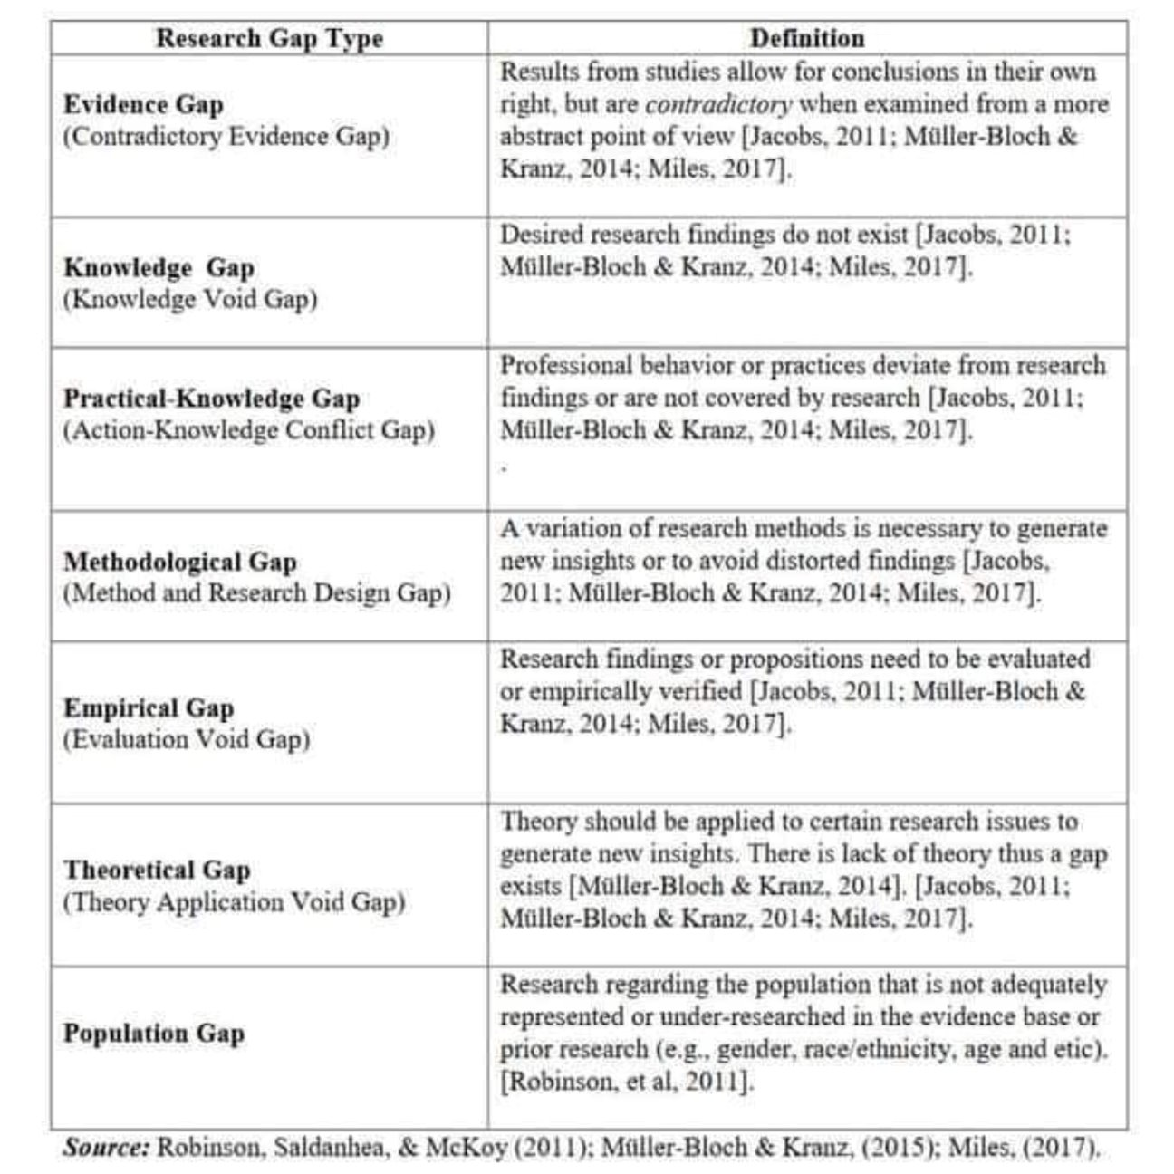

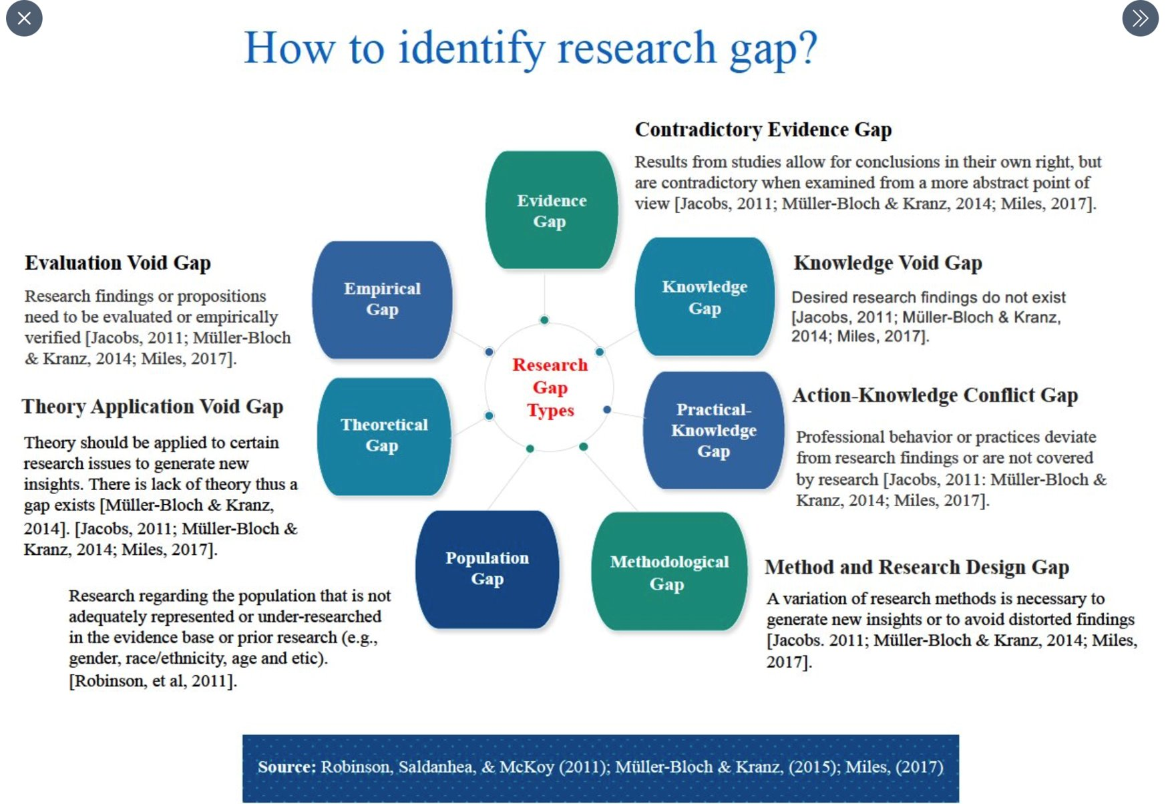

**Readings: Week 2**

**Designing Social Inquiry – Scientific Inference in Qualitative Research**

**Chapter 2 – Descriptive Inference**

We cannot construct meaningful causal explanations without good description; description, in turn, loses most of its interest unless linked to some causal relationships. Description often comes first; it is hard to develop explanations before we know something about the world and what needs to be explained on the basis of what characteristics. But the relationship between description and explanation is interactive. Sometimes our explanations lead us to look for descriptions of different parts of the world; conversely, our descriptions may lead to new causal explanations.

There are several fundamental aspects of scientific description. One is that it involves inference: part of the descriptive task is to infer information about unobserved facts from the facts we have observed. Another aspect involves distinguishing between that which is systematic about the observed facts and that which is nonsystematic.

In this chapter, we distinguish description—the collection of facts— from descriptive inference.

In the human sciences, some historical and anthropological researchers claim to seek only specific knowledge through what they call “interpretation.” Interpretivists seek accurate summaries of historical detail. They also seek to place the events they describe in an intelligible context within which the meaning of actions becomes explicable. Perhaps the single most important operational recommendation of the interpretivists is that researchers should learn a great deal about a culture prior to formulating research questions. For only with a deep cultural immersion and understanding of a subject can a researcher ask the right questions and formulate useful hypotheses. Some scholars push the role of interpretation even further, going so far as to suggest that it is a wholly different paradigm of inquiry for the social sciences, “not an experimental science in search of law but an interpretive one in search of meaning.” In our view, however, science (as we have defined it in section 1.1.2) and interpretation are not fundamentally different endeavours aimed at divergent goals. Both rely on preparing careful descriptions, gaining deep understandings of the world, asking good questions, formulating falsifiable hypotheses on the basis of more general theories, and collecting the evidence needed to evaluate those hypotheses. The distinctive contribution of science is to present a set of procedures for discovering the answers to appropriately framed descriptive and causal questions.

One of the best and most famous examples in the interpretative tradition is Clifford Geertz’s analysis of Gilbert Ryle’s discussion of the difference between a twitch and a wink. Geertz (1973:6) writes:

*Consider . . . two boys rapidly contracting the eyelids of their right eyes. In one, this is an involuntary twitch; in the other, a conspiratorial signal to a friend. The two movements are, as movements, identical; from an I-am-acamera, “phenomenalistic” observation of them alone, one could not tell which was twitch and which was wink, or indeed whether both or either was twitch or wink. Yet the difference, however unphotographable, between a twitch and a wink is vast; as anyone unfortunate enough to have had the first taken for the second knows. The winker is communicating, and indeed communicating in a precise and special way: (1) deliberately, (2) to someone in particular, (3) to impart a particular message, (4) according to a socially established code, and (5) without cognizance of the rest of the company. As Ryle points out, the winker has done two things, contracted his eyelids and winked, while the twitcher has done only one, contracted his eyelids. Contracting your eyelids on purpose when there exists a public code in which doing so counts as a conspiratorial signal is winking.*

Geertz is making an important conceptual point. Without the concept of “winking,” given meaning by a theory of communication, the most precise quantitative study of “eyelid contracting by human beings” would be meaningless for students of social relations. In this example, the theory, which emerged from months of “soaking and poking” and detailed cultural study, is essential to the proper question of whether eyelid contraction even could be “twitches” or “winks.”

Inherent uniqueness, therefore, is part of the human condition: it does not distinguish situations amenable to scientific generalizations from those about which generalizations are not possible. The point is not whether events are inherently unique, but whether the key features of social reality that we want to understand can be abstracted from a mass of facts. One of the first and most difficult tasks of research in the social sciences is this act of simplification. It is a task that makes us vulnerable to the criticism of oversimplification and of omitting significant aspects of the situation. Indeed, the difference between the amount of complexity in the world and that in the thickest of descriptions is still vastly larger than the difference between this thickest of descriptions and the most abstract quantitative or formal analysis. There is no choice but to simplify. Systematic simplification is a crucial step to useful knowledge. As an economic historian has put it, if emphasis on uniqueness “is carried to the extreme of ignoring all regularities, the very possibility of social science is denied and historians are reduced to the aimlesssness of balladeers” (Jones 1981:160). **the best way to understand a particular event may be by using the methods of scientific inference also to study systematic patterns in similar parallel events.**

If quantification produces precision, it does not necessarily encourage accuracy, since inventing quantitative indixes that do not relate closely to the concepts or events that we purport to measure can lead to serious measurement error and problems for causal inference (see section 5.1).

**To provide an insightful description of complex events is no trivial task. In fields such as comparative politics or international relations, descriptive work is particularly important because there is a great deal we still need to know, because our explanatory abilities are weak, and because good description depends in part on good explanation**

One of the often overlooked advantages of the in-depth case-study method is that the development of good causal hypotheses is complementary to good description rather than competitive with it.

**For example, Alexander George recommends a method of “structured, focused comparison” that emphasizes discipline in the way one collects data (George and McKeown 1985; see also Verba 1967). George and his collaborators stress the need for a systematic collection of the same information—the same variables—across carefully selected units. And they stress the need for theoretical guidance—for asking carefully thought-out explanatory questions—in order to accomplish this systematic** if causal inference is to be ultimately possible.

**The method of structured, focused comparison is a systematic way to employ what George and McKeown call the congruence procedure. Using this method, the investigator “defines and standardizes the data requirements of the case studies . . . by formulating theoretically relevant general questions to guide the examination of each case”**

**“Controlled comparison of a small n should follow a procedure of systematic data compilation.” Such “structuredfocused comparison” requires collecting data on the same variables across units. Thus, it is not a different method from the one that we emphasize here so much as it is a way of systematizing the information in descriptive case studies in such a way that it could conceivably be used for descriptive or causal inference. Much valuable advice about doing comparative case studies, such as this, is rudimentary but often ignored.**

INFERENCE: THE SCIENTIFIC PURPOSE OF DATA COLLECTION Inference is the process of using the facts we know to learn about facts we do not know. The facts we do not know are the subjects of our research questions, theories, and hypotheses. The facts we do know form our (quantitative or qualitative) data or observations.

Second, we need not have a complete theory before collecting data nor must our theory remain fixed throughout. Theory and data interact.

“If my explanation is correct of why the decision came out the way it did, what else might I expect to observe in the real world?”

A model is a simplification of, and approximation to, some aspect of the world. Models are never literally “true” or “false,” although good models abstract only the “right” features of the reality they represent.

What rules govern the summary of historical detail? The first rule is that summaries should focus on the outcomes that we wish to describe or explain. If we were interested in the growth of the average international organization, we would not be wise to focus on the United Nations; but if we were concerned about the size distribution of international organizations, from big to small, the United Nations would surely be one of the units on which we ought to concentrate. The United Nations is not a representative organization, but it is an important one. In statistical terms, to investigate the typical international organization, we would examine mean values (of budgets, tasks, memberships, etc.), but to understand the range of activity, we would want to examine the variance. A second, equally obvious precept is that a summary must simplify the information at our disposal.

DESCRIPTIVE INFERENCE Descriptive inference is the process of understanding an unobserved phenomenon on the basis of a set of observations. For example, we may be interested in understanding variations in the district vote for the Conservative, Labour, and Social Democratic parties in Britain in 1979. We presumably have some hypotheses to evaluate; however, what we actually observe is 650 district elections to the House of Commons in that year. Naively, we might think that we were directly observing the electoral strength of the Conservatives by recording their share of the vote by district and their overall share of seats. But a certain degree of randomness or unpredictability is inherent in politics, as in all of social life and all of scientific inquiry.7 Suppose that in a sudden fit of absentmindedness (or in deference to social science) the British Parliament had agreed to elections every week during 1979 and suppose (counterfactually) that these elections were independent of one another. Even if the underlying support for the Conservatives remained constant, each weekly replication would not produce the same number of votes for each party in each district. The weather might change, epidemics might break out, vacations might be taken—all these occurrences would affect voter turnout and electoral results.

One of the fundamental goals of inference is to distinguish the systematic component from the nonsystematic component of the phenomena we study. The systematic component is not more important than the nonsystematic component, and our attention should not be focused on one to the exclusion of the other. However, distinguishing between the two is an essential task of social science.

The political world is theoretically capable of producing multiple data sets for every problem but does not always follow the needs of social scientists. We are usually only fortunate enough to observe one set of data. For purposes of a model, we will let this one set of data be represented by one variable y (say, the vote for Labor) measured over all n = 650 units (districts): y1, y2, ..., yn (for example, y1 might be 23,562 people voting for Labor in district 1). The set of observations which we label y is a realized variable. Its values vary over the n units. In addition, we define Y as a random variable because it varies randomly across hypothetical replications of the same election. Thus, y5 is the number of people voting for Labor in district 5, and Y5 is the random variable representing the vote across many hypothetical elections that could have been held in district 5 under essentially the same conditions. The observed votes for the Labor party in the one sample we observe, y1, y2,..., yn, differ across constituencies because of systematic and random factors. That is, to distinguish the two forms of “variables,” we often use the term realized variable to refer to y and random variable to refer to Y.

**Silencing to Give Voice: Backstage Preparations in the Undocumented Youth Movement in Los Angeles**

Building upon intensive ethnographic research on the undocumented youth movement in Los Angeles, this paper investigates the backstage work done by the leaders and activists within a movement to create cohesive and disciplined frontstage performances. These backstage techniques and strategies are important to examine because frontstage unity is not natural or automatic. As most campaigns are made up of heterogeneous individuals, organizations and groups, frontstage coherence is something that needs to be worked upon. We show that this essential backstage work consists of 1) training activists to become disciplined frontstage performers; 2) converging the feelings of activists through emotionally intensive disciplinary techniques; and 3) managing differences and conflicts in the free spaces of the movement. This paper thus aims to encourage scholars to look under the hood of public protests and give greater weight to studying the backstage work needed to produce strong and powerful voices.

Much of the empirical data presented in this article stems from six months of intensive ethnographic fieldwork conducted by the first author from September 2011 till March 2012. The sample consists of a core group of about 60 DREAMers, the majority of which have a Mexican or Latino background and live in the wider Los Angeles area. Most of the fieldwork was conducted at one of the most important local DREAM organizations in the country: Dream Team Los Angeles (DTLA).

Through the strong connections with DTLA, participant observation was also conducted with other DREAMer organizations in California, such as California Dream Network, Orange Country Dream Team (OCDT), San Fernando Valley Dream Team (SFVDT) and San Gabriel Valley Dream Team (SGVDT). Los Angeles is a very suitable locale to study the DREAM movement, because the city—and wider region—has many Latino migrants, a long history of immigrant rights mobilizing, and a very active and well-developed undocumented students movement.

**Legate, N., Ngyuen, T. V., Weinstein, N., Moller, A., Legault, L., Vally, Z., ... & Ogbonnaya, C. E. (2022). A global experiment on motivating social distancing during the COVID-19 pandemic. *Proceedings of the National Academy of Sciences*, *119*(22).**

**As you read Legate et al. (2022), consider:**

*The role of theory in shaping research questions and hypotheses*

What are the research aims and hypotheses? What role does theory play in these aims and hypotheses?

1. Three research aims were supported by this design.
2. First, we aimed to determine the extent to which brief written autonomy-supportive and controlling messages differentially affect motivation, feelings of defiance, and behavioural intentions to follow social distancing recommendations. We did not track social distancing adherence over time due to varied resources across the many data collection laboratories and opted to measure behavioural intentions (both short and long term) for social distancing instead. Behavioural intentions or plans to perform behaviour (24) are a key determinant of behavioural adherence and a common outcome for health behaviour interventions (24,25).
3. A second aim was to determine whether the differential effects of autonomy-supportive and controlling messages generalize across a geographically diverse sample (26).
4. Finally, we aimed to test associations between motivations to follow social distancing recommendations and feelings of defiance and behavioural intentions.
5. Hypothesis 1: Compared with the controlling message, those in the autonomy-supportive message and no-message conditions will report 1) higher internalized motivation to socially distance,2) lower feelings of defiance, and 3) higher short-term (one-week) and long-term (six-month) intentions to socially distance. In other words, we expected the autonomy-supportive message to have benefits over the controlling message and the controlling message to have worse outcomes compared with no message at all.
6. Hypothesis 2: Autonomous motivation for social distancing will be associated with 1) lower feelings of defiance and greater short-term (one-week) and long-term (six-month) intentions to socially distance, while controlled motivation will 2) have inverse associations with defiance and behavioural intentions.
7. What role does theory play in these aims & hypotheses 0 Self-determination theory - SDT has long investigated the effects of communication style on the quality, quantity, and sustainability of people’s motivation to change their behaviour. Autonomy supporting vs controlling.

*Results of the study*

What did the authors find? Did their analysis support the theory’s predictions?

1. *H1 - Autonomous and Controlled Motivation:* We did not find evidence that the autonomy-supportive message condition meaningfully yielded higher autonomous motivation than the controlling message condition (rp=0.034, 95% CI [0.021, 0.046]), nor did we find evidence that those in the no-message condition reported higher autonomous motivation than those in the controlling message condition (rp=–0.012, 95% CI [–0.024, 0.001]). Across all message conditions, controlled motivation was moderate. Those in the no-message condition showed lower controlled motivation than those in the controlling message condition (rp=–0.096, 95% CI [–0.108, –0.084]). However, we did not find evidence of a difference in controlled motivation between the autonomy-supportive message and controlling message conditions (rp=–0.026, 95% CI [–0.039, –0.014]).
2. *H1 - Feelings of defiance.* Across conditions, feelings of defiance were low. The autonomy-supportive message led to lower feelings of defiance than the controlling message (rp=–0.064, 95% CI [–0.076, –0.052]). However, we did not find a difference between the no-message and the controlling message conditions (rp=–0.003, 95% CI [–0.015, 0.000]).
3. *H1 - Short and long-term behavioural* - intentions. People generally intended to socially distance in the next week and intended to continue socially distancing for the majority of the next six months. The autonomy-supportive message condition did not yield differences in one-week social distancing intentions from the controlling message condition (rp=0.009, 95% CI [0.001,0.021]), nor did the no-message condition (rp=0.017, 95%CI [0.005, 0.029]). Similarly, the autonomy-supportive message condition did not yield differences in social distancing intentions in the next six months from the controlling message condition (rp=–0.010, 95% CI [–0.023, –0.001]), nor did the no-message condition (rp=–0.001, 95% CI [–0.014,0.000]). Thus, we did not find that conditions differed in short- or long-term behavioural intentions to socially distance.
4. *H2 - Feelings of defiance.* As expected, autonomous motivation predicted lower feelings of defiance (rp=–0.522,95% CI [–0.530, –0.514]). Additionally, controlled motivation predicted higher feelings of defiance (rp=0.223, 95% CI [0.211, 0.234]).
5. *H2 - Short- and longer-term behavioural intentions.* Autonomous motivation was associated with greater intentions to socially distance in the next week (rp=0.433, 95% CI [0.423, 0.442]), whereas controlled motivation was not related to short-term behavioural intentions (rp=–0.006, 95% CI [–0.018, 0.000]). Autonomous motivation was positively associated with behavioural intentions to socially distance in the next six months (rp=0.465, 95% CI [0.456, 0.474]), whereas controlled motivation was negatively associated with longer-term behavioural intentions (rp=–0.102, 95% CI [–0.114, –0.090]).
6. We found evidence for two confirmatory experimental effects. 1) The controlling, pressuring message increased con-trolled motivation to follow recommendations out of guilt and fear of social punishment more than the messages to which participants had been previously exposed. 2) The autonomy-supportive message that promoted agency and ownership lowered feelings of defiance relative to the controlling message.

**Week 2 – Lecture: Theory & Data**

* “Theory” comes from the Greek word “*theoria*” = “viewing”: ***a way of viewing the world.***
* “A set of concepts used to define and/or explain some phenomenon” (Silverman, 2010)
* “[A]n explanation of observed regularities” (Bryman, 2016)
* “[T]heory consists of plausible relationships produced among concepts or sets of concepts” (Strauss & Corbin, 1994)
* ***Grand theories:*** generally attempt to explain how societies change over time, the nature of things (meta-narratives, a world view): e.g. Foucault power-knowledge, rational choice theory
* ***Middle-range theories:*** guide empirical inquiry and explore more specific/localised processes: e.g. often associated with specific phenomena or sub-fields of research (do you have an example?)

Why use theory?

* To focus our attention when we are faced with expansive possible topics or explanatory variables.
* To make our assumptions explicit and terms clear.
* To be part of the cumulative development of science.
* Drawing on existing knowledge from other areas
* Contributing to knowledge that applies across substantive areas
* To offer a potentially productive new insight or angle on a field.

“Concepts are the building blocks of the social sciences, as they are of all sciences. There is no theory without concepts, there is no description without concepts, and there is no explanation without concepts." - (Munck, Møller J and Skaaning 2020)

“A large proportion of the literature treating specific problems and of the propaganda for new ideas and theories is so ably presented and so logically reasoned that there is a distinct tendency to be convinced by the soundness of the reasoning without a careful analysis of the data used, and whether or not all factors affecting the problem have been included.”

John Candler Cobb in “The Significance and Use of Data in the Social Sciences”, *The Economic Journal*, 1928, Vol. 38, No. 149, pp. 63-75.

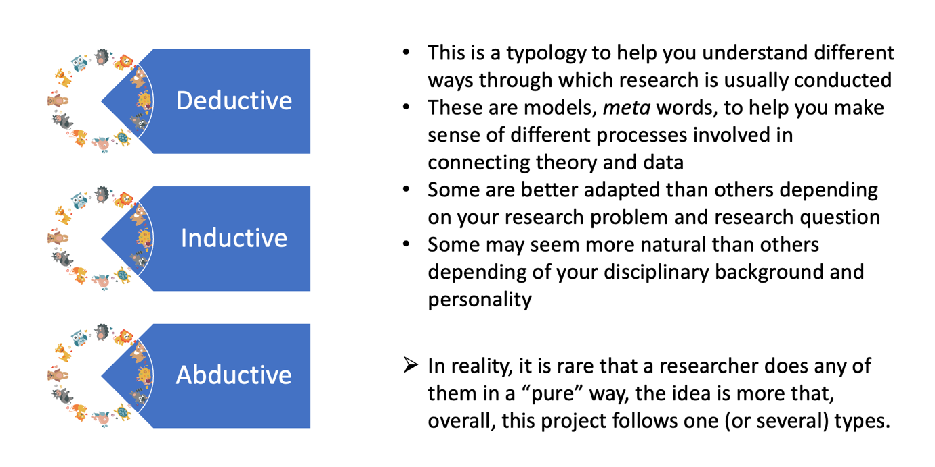

Deduction

* In the UK, you have to be at least 17 to get a drivers licence. Maya has a UK drivers licence. → Maya must be at least 17 years old.
* Theory X tells us that this is so.
* If this is so, then in this context, A and B should be associated in this way. [hypothesis; null & alternative]
* Study evaluates whether or not this association is there.
* General form: Start with a general theory; deduce testable, falsifiable hypotheses.

Induction

* I often notice that just before it rains, the air gets cool. The air just started to get cool. → It is probably about to rain (because there’s probably some connection between rain and the air temperature).
* Inductive logic is often more typical with exploratory and qualitative analyses, and is more closely associated with social science disciplines like sociology and anthropology.
* General form: observe a number of instances; produce an abstraction or generalisation about a class of instances.

Abduction

* When some surprising, astonishing phenomenon is observed, we need to revise our conceptions of the world to account for it — we need to develop new theory that means that the phenomenon is no longer an anomaly.
* Often starts with a puzzle then “Inference to the best explanation” — from among the set of tentative hypotheses that could reconcile this anomalous observation, the best is/are selected and investigated.
* Example: this is the type of reasoning that is often used in detective investigations: https://youtu.be/zl8NQ2j2S9Y
* Theory provides:
  + “Ways of seeing”
  + Articulation of concepts to guide analysis
* Data provides:
  + Instantiations of these concepts (illustrations of what the phenomena referred to by concepts looks like)
* Analysis produces:
  + Novel ways of thinking about a topic
  + Avenues for future action (e.g. further research or applied practice)

Designing Research is Challenging

* Making your own research design decisions is challenging
  + Which theory should I use?
  + Which concepts should I use?
  + Which data should I use?
  + How should I start? Should I rather adopt a deductive, inductive or abductive approach?

To help you in making these decisions, you need:

* To expand your imagination by reading things that will inspire your work and show you examples of what has been done
* To understand the different options and identify the one best adapted to your research project (remember that every decision involves a trade-off, there is rarely a perfect option)
* Internalise criteria of good research design by revising the module and reading the methodological literature!

**Week 2 – Seminar: Theory & Data**

Ensure linguistic congruence between research questions and hypotheses.

**Week 3 – Readings:**

**Oakley, A. “Gender, Methodology and People’s Ways of Knowing: Some Problems with Feminism and the Paradigm Debate in Social Science.” *Sociology,* 32(4), 707-731, 1998.**

The debate about research methods is more than a dialogue/argument concerning the best research techniques to use in which circumstances, it offers a narrative which is about the relations between the social and scientific division of labour, the cultural production of masculinities and femininities, and the processes used to establish an understand of the social and material world.

Methodology is itself gendered, and one of the chief functions of the quantitative/qualitative dichotomy is as an ideological representation.

Need to understand intellectual and social origins of both social and natural science, and history of relationship between.

Issue with positivism, power (researcher vs. subject) & p values. Apex of the feminist critique of quantitative methods is reached in relation to experimental studies. Core of natural science as thus an essential reason for its rejection by advocates of a human social science. Feminist case against quant is seemingly unbridgeable, there is a contradiction within the phrase ‘feminist social science’, because a science, if it is feminist, cannot be scientific. Science is the enemy.

Difference between sociology ‘of’ women and ‘for’ women - “Smith suggests the notion of a feminist ‘standpoint’ as a place outside the dominant frame of organised social science knowledge from which it is possible to construct a sociology respectful of women’s subjectivity.”

Issues with women-only samples, sharing royalties, etc. on page 714. Those who claim that qual techniques protect from research bias ignore the selection process inherent in the collection and reporting of data, which by no means save it from ‘the intrusion of the researcher’s values.’ ‘you do not escape the difficulties by pretending that you can extract unproblematic information yourself in a pub over a pint of beer.

Logic of quantification as a strategy for imposing distance. Move from metaphysics to empiricism as a way of establishing knowledge about the world. Removal of values a way of separating valid and invalid knowledge.

Today, most feminist crittics of quant methods do concede that there is a social reality which has an objective existence beyond people’s competing interpretations of it. Issue with rooting knowledge in the description of individual experiences is that one never moves beyond them. Need to alter malestream methods rather than abandon the methodological techniques themselves.

Dichotomy is neither a property of nature nor of human life and experiences. The conception of an opposition between two elements that denies the existence of any middle ground between them could not have been derived empirically, it is, rather, itself a social construction informed by a basic requirement of patriarchal societies, which is the rule of a clear opposition between men and women.

**Fatehkia, M., Kashyap, R. Weber, I. “Using Facebook ad data to track the global digital gender gap,” *World Development,* 107, 189-209, 2018.**

Our results demonstrate the feasibility of using Facebook data to measure digital gender gaps around the world. Models using only online Facebook data do better than models using only offline indicators for predicting internet gender gaps as reported in official ITU statistics. Models combining Facebook data with offline gender equality indicators however do the best. With the online model using Facebook data, we estimate a mean value of the internet gender gap index for low-income countries to be 0.76. This implies that 0.76 women have access to the internet for every man who does, indicating that female internet penetration is 24% lower than that for males. This index increases to 0.86 for lower-middle income countries and to 0.92 and 0.95 for upper-middle and high income countries respectively based on the World Bank’s classification. For the mobile phone gender gaps our online model predicts a gender gap index of 0.79 for low income countries indicating a female deficit in mobile access of 21%. This increases to 0.90 and 0.96 for lower-middle and upper-middle income countries respectively, with high income countries having an index of 0.98.

Lack of standardised data availability with broad coverage.

Based on data compiled from countries with available survey data, the ITU estimates that while about 45% of men in developing countries were using the internet, 37.5% of women were using the internet in the same (ITU, 2017).4 For the least developed countries they estimate male internet penetration to be 21%, compared to female internet penetration of 14%. The female internet penetration rate here is defined as the proportion of women, as a fraction of the female population, who have access to the internet (ITU, 2017). For mobile phones, the GSMA, a trade body representing the interests of mobile operators worldwide, estimates that 59% of women in the world do not own mobile phones whereas 74% of men do

The results were very promising with a regression model based solely on Facebook’s gender gap explaining 69% of the variance in the ground truth Internet Gender Gap Index that we computed using ITU data. In the absence of Facebook data, these results could not be matched even when combining several offline measures of a country’s development and levels of gender inequality. Although models with the Facebook measure alone performed well, models with the most predictive power combined both online and offline variables, either as multivariate models or through the use of biascorrection factors.

**Lecture: Week 3 – Literature Review**

What are the challenges of a literature review?

Reviewing the literature constitutes 2/3 of the research project process.

Step 3:

* Identify what disciplines you are interested in.
* What alternative language or words could be used to examine the same research but in different disciplines.
* Discipline (epistemology) and method (ontology).
* Dinner party thought experiment – which academics would I want to invite to a conversation around what I’m researching?

Scraping or accessing information through an API (Application Programming Interface) is **primary** data collection.

A systematic review answers a defined research question by collection and summarising all empirical evidence that fits pre-specified eligibility criteria.

A meta-analysis is the use of statistical methods to summarise the results of these studies.

**MUST** signpost relevant information and relevance to study.

Substitution – implies strategic decision making – feasibility – relative power – structural theory of aggression. Operationalised across core concepts in data terms.

Abstraction to concrete evidence to abstraction – Eric Hayot’s Uneven U. Useful modell for building paragraphs that leads to broader argument.

1. Concrete evidence/existing study
2. Description, interpretation, smmary
3. Conceptual, broad examples, common themes
4. Problem orientated, pulling ideas together, contribution,
5. Abstract; statement towards a solution and conclusion.

Using tables to present literature?? Could do this.

**Seminar: Week 4 – Literature Review**

**Subjectivity**

* Research design is shaped by personal experiences and opinions of the researcher.
* Subjectivity brings different viewpoints to the same topic.
* Subjectivity can throw open new research questions.
* Subjectivity can lead to bias, which bad, but subjectivity is not necessarily bad.

**Objectivity**

* Transparency around assumptions.
* Comprehensive in material selection & thus unbiased.
* Address both sides of a dispute.
* Often treated as sufficient justification for pursuit of research.

**Is Subjectivity/Objectivity useful?**

* Does the dichotomy hold?
* In what circumstances might it be useful?

Haraway, D. “Situated Knowledges: The Science Question in Feminism and the Privilege of Partial Perspective,” *Feminist Studies,* 14(3), 575-599, 1988. https://www.jstor.org/stable/3178066

**Literature Review material:**

* Frederic S. Pearson & Robert A. Baumann “International military interventions: Identification and classification, International Interactions,” 14:2, 173-180, 1988. 10.1080/03050628808434701
* Escribà-Folch, A., Wright, J. “Military Intervention and Regime Change,” in A. Escribà-Folch & J. Wright (eds.) *Foreign Pressure and the Politics of Autocratic Survival,* Oxford, Oxford University Press, 2015.
* Vertzberger, Y. “Risk Taking and Decision Making: Foreign Military Intervention Decisions,”
* Democratic Jihad? Military Intervention and Democracy1
* <https://academic.oup.com/isq/article/49/1/23/1793155?login=true>
* <https://www.sipri.org/sites/default/files/SIPRIYB0902.pdf>

**Readings: Week 4 –**

Munck, G., Møller, J., Skaaning, S. “The SAGE Handbook of Research Methods in Political Science and International Relations” Conceptualization and Measurement: Basic Distinctions and Guidelines.”

Sartori (1970: 1038) put it, because we cannot measure something if we have not specified its meaning, ‘concept formation stands prior to quantification'. Or, more broadly, as Bunge (1995: 3; 2012: 122) argues, ‘concept formation precedes empirical test’ and ‘in concept formation quality precedes quantity’ (see also Lazarsfeld and Barton, 1951: 155–6). Thus, researchers need to focus on the formation of concepts and to recognize the qualitative foundations of all research.

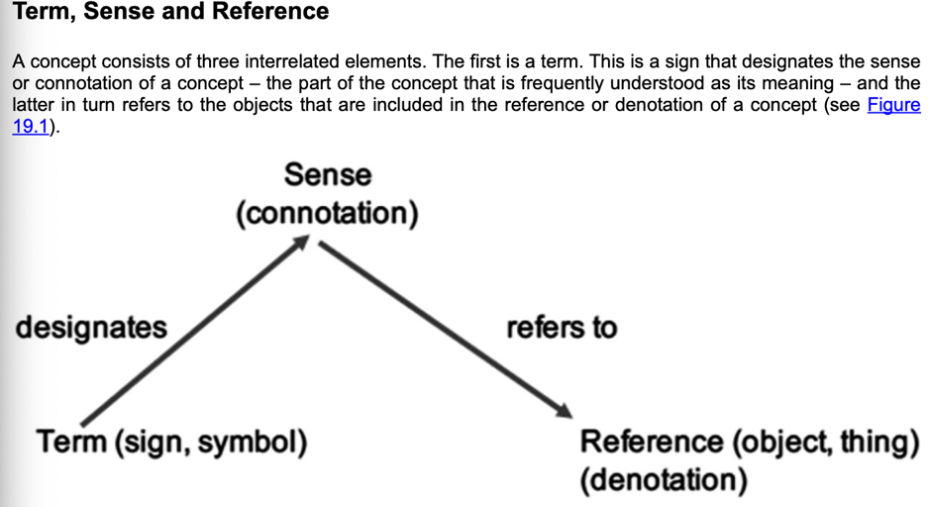

**The Attributes and Structure of a Concept**

Turning to a more detailed discussion of a concept's sense, it is critical to recognize that a concept's sense is conveyed by (i) the conceptual attributes that represent properties of objects and (ii) the relationship among conceptual attributes or, for short, the structure of a concept. For this reason, the meaning of concepts is not fully conveyed by a simple listing of conceptual attributes, a common feature of definitions.

Listing the defining attributes of a concept is useful. It puts the focus on what conceptual attributes should be included in a concept. Moreover, inasmuch as a definition also clarifies what conceptual attributes should be excluded from a concept (even though they are included by some scholars), such an exercise is critical. For example, one of the ongoing concerns in the discussion about the concept of democracy is how to strike the right balance between expanding the concept of democracy beyond the sphere of elections. This can, for example, be done by adding attributes considered to be part of democracy (e.g. horizontal accountability), and expanding the concept of democracy in such a way that what might be considered extraneous attributes are included in the concept of democracy (e.g. the economic equality of citizens) (Munck, 2016).

However, it is important to note that any such list offers an incomplete sketch of a concept. Indeed, inasmuch as more than one conceptual attribute is posited, it is necessary to inquire about the structure of a concept, which is given by the relationships among conceptual attributes at the same level (horizontal relationships) and at different levels (vertical relationships) (see Figure 19.2). That is to say, the meaning of a concept might not be conveyed by each attribute taken individually, in an additive manner, and the structure of a concept could be key to its meaning. Thus, to fully and correctly grasp the meaning of a concept, it is crucial to appreciate that concepts can be – indeed, usually are – conceptual systems, which in turn are part of larger conceptual systems or semantic fields

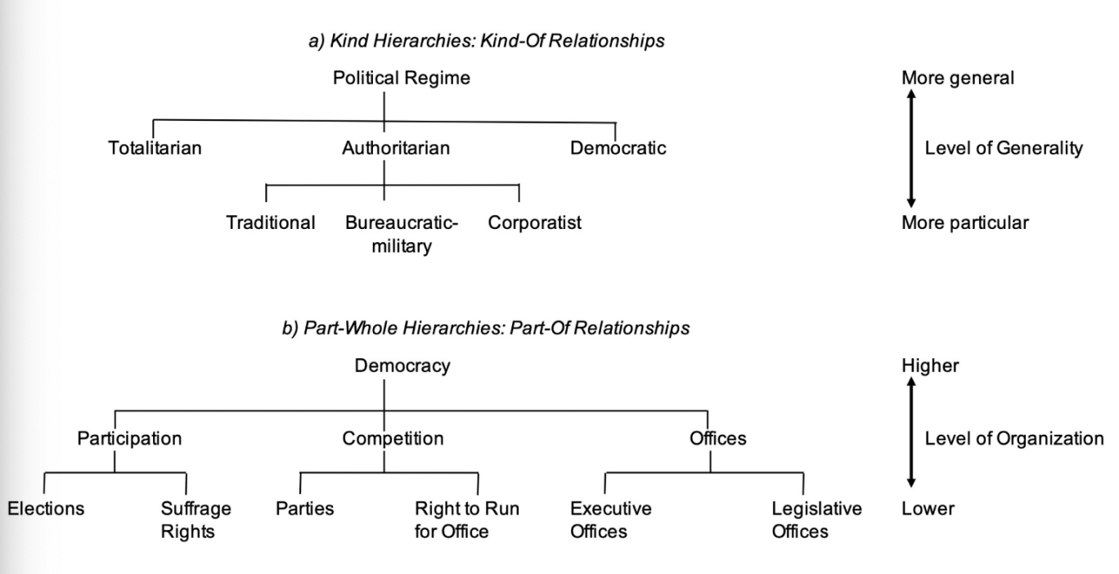

Concepts are not true or false. Nonetheless, not all concepts rest on an equally sound foundation; some have been carefully elaborated and justified, while others are merely stipulated without much in the way of reflection. Without making any claim to exhaustiveness, we propose a set of criteria to assess whether concepts are good or bad. Most basically, concepts have to be intelligible. This means that we should be able to answer the following questions: what is the concept designed by the term or symbol used for? What are the conceptual attributes? What is the structure of a concept, that is, what are the relationships among conceptual attributes? What is the reference of a concept?

It bears noting that the assumption underpinning this criterion – that concepts can and should be assessed in light of their theoretical justification – is not universally accepted. On the one hand, many scholars posit that a number of concepts, and especially those that have an obvious normative connotation, are ‘essentially contested’ and that they will always remain ‘open’ in the sense that a research community will never agree on a definitive definition (Gallie, 1956; Gray, 1978).

**Measurement & Operationalisation**

Due to the nature of indicators, probably the hardest challenge in the design of a measuring instrument relates to what is usually called content validity – the extent to which one or more indicators capture the correct and full sense or content of the concept being measured (Adcock and Collier, 2001: 536–40). The goal of measurement is to generate data that can be used to evaluate the truth of claims about facts (e.g. the US is a democracy in 2019). But data will be useful for this purpose only inasmuch as any data collected on some indicators can be linked back to the concept (e.g. the concept of democracy in this example) used in a factual claim. Building such bridges is anything but an easy task, especially when the concept of interest is multidimensional, that is, has many conceptual attributes.

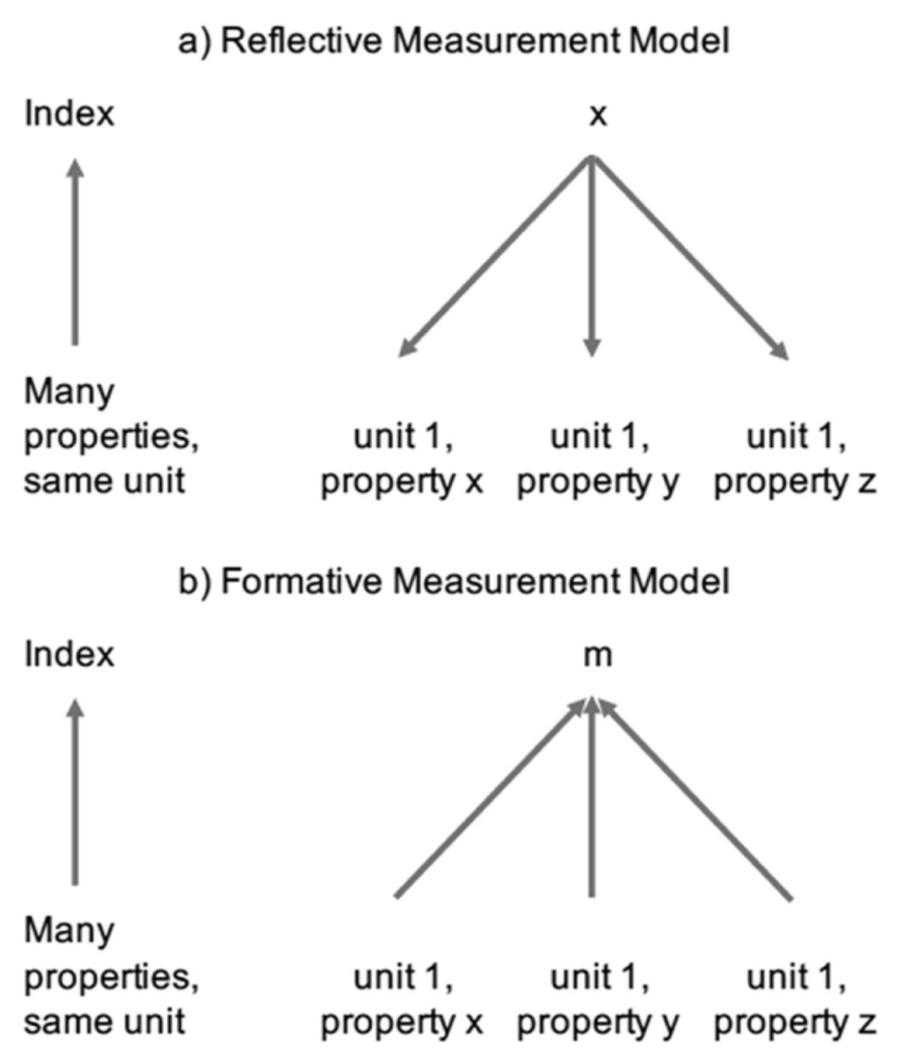

**Week 5: Seminar – Operationalisation & Measurement**

**Operationalization**

* **Defining the measurement of a phenomenon that we can not directly observe.**
* **Measurable either quantitatively or qualitatively.**
* **The *dimensions* which make up a variable.**

**Measuring poverty and conceptualisation: what is the question?**

* Monetary approach (World Bank)
  + Do people have enough money?
* Capability approach (Amartya Sen)
  + Do people have the range of capabilities they need to adequately function in the world?
* Social Exclusion approach
  + Are people excluded from full participation in society?
* Participatory approach
  + Do people think they are poor?

Each conceptualisation of poverty implies answering a different question.

* What variable are you measuring?
* What context are you studying?
* What is your data source?
* What informs your operationalisation?

**Class Exercise: Operationalising & Measuring Women’s Empowerment**

**Week 5: Lecture – Ethics, Reflexivity & Writing**

Ethical Principles

* Avoidance of harm
* Beneficence – doing good
* Autonomy – voluntary informed consent
* Justice – right to respect, dignity and privacy
* Anonymity and confidentiality

Procedural ethics

* Institutional
  + Rigid due to organisation

Everyday ethics in research

* Developing an ethical sensibility and a reflexive practice
  + Good norms
  + Good practice

Ethical Sensibility

* Strategies to identify where ethical questions might arise (procedural ethics help to identify).
* When things change in the context(s) you study and unexpected ethical questions arise, you can handle them better.
* Reflexivity helps building ethical sensibility

Preparedness and due diligence (before, during, after)

* Knowledge of context
* Consensual relationships you build
* Treating participants with dignity and respect – how would you feel as a subject of this research?

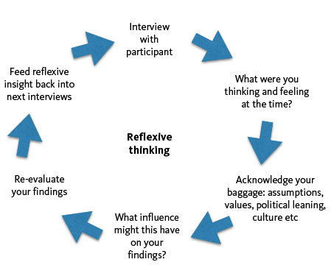

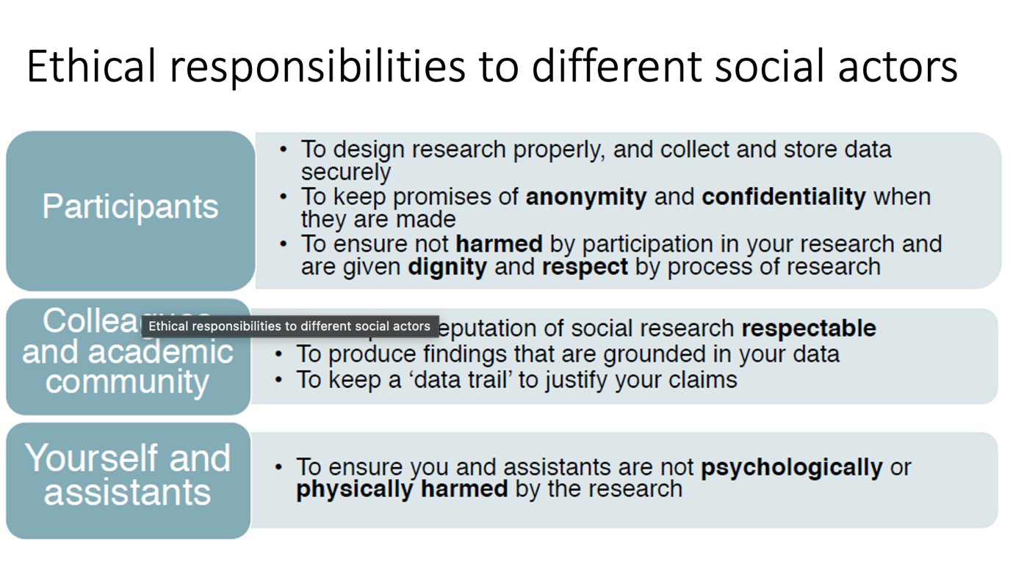

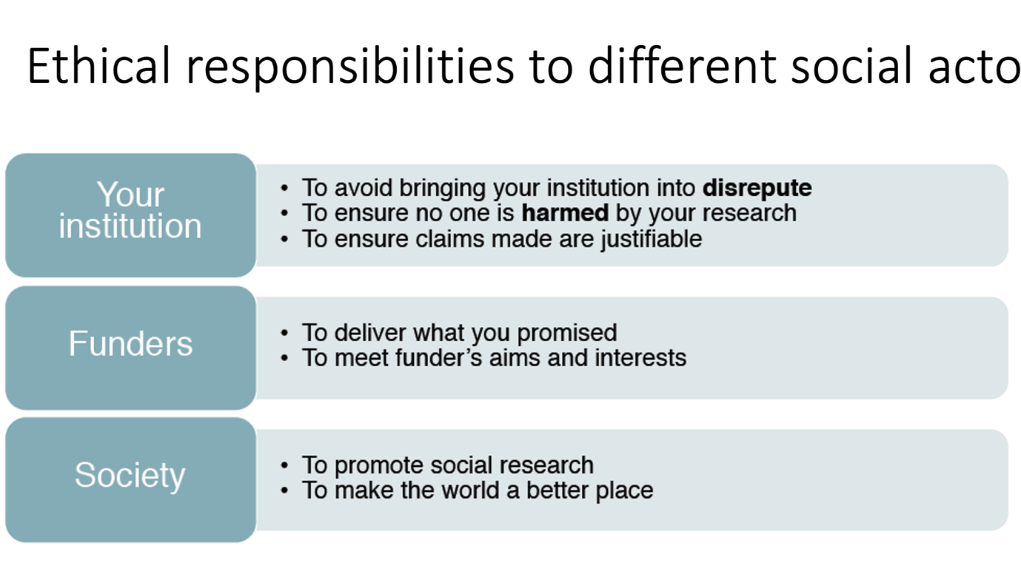

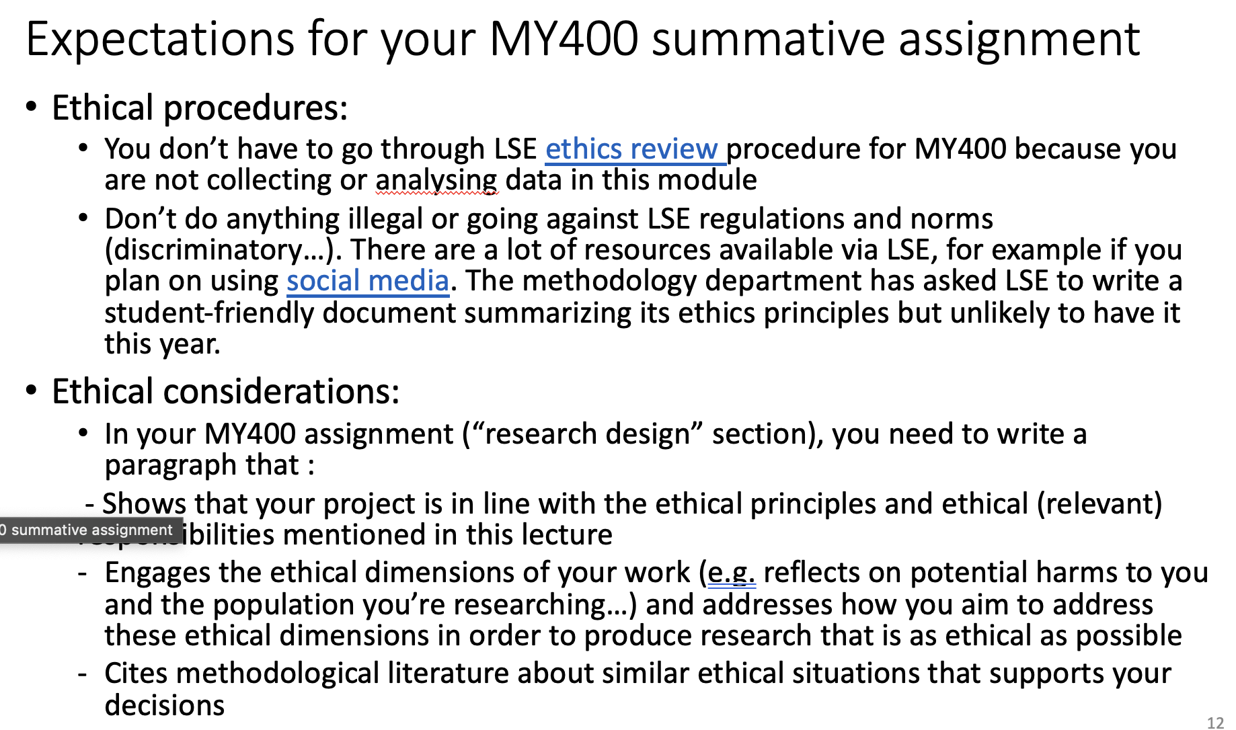

**REFERENCE SPECIFIC PRINCIPLES IN SUMMATIVE**

Is there research that can potentially harm someone? What do I need to keep in mind?

**Writing**

* **The goal is to *convey* an argument**
  + Argumentative writing, demonstration and transparency are key. What have we learned, and what have we not learned?
* The goal is not to *win* an argument
  + Hiding problems and using misleading language may fool readers sometimes, but when they notice they will (rightly) distrust everything else you say.

Structure

* Goal is to convey an argument – do so in introduction. TARGET supervisor.
* Literature review: what do we already know?
* Research Question: What is something that we do not know that we could figure out?
* How do methods chosen relate to RQ?
* Data collection: what evidence can we collect/have we collected?
* Data analysis: does how the evidence relate to research question?
* Results: what have we learned?
* Conclusion: So what? What have we contributed to what was already known?
* A paragraph is a unit of meaning
  + One main idea per paragraph
  + Only one main idea per paragraph, if there is another main idea create two paragraphs
* Structure your paragraphs instead of just putting one sentence after the other
  + For example: ‘Within this tradition, scholarship has put forward three different ways of interpreting the problem of X. First,… Second,… Third, …

**Reflexivity**

* We are all socialised in ways of speaking, thinking, assumptions...
* These dispositions mediate the way we perceive the world and produce and communicate knowledge
* Depending on your epistemology, you might call it “bias”, “positionality”, “situatedness”…
* This raises two intertwined methodological problems about the:
* Validity and rigour of the knowledge we produce
* Ethical and socio-political implications of the knowledge we produce

**‘Reflexivity is the practice of making conscious and explicit our practices, beliefs and dispositions.’ (Alejandro 2021a, 152)**

**‘Practically understood, reflexivity is the practice of putting our everyday behaviors, beliefs, values, and discourses into perspective. By highlighting the social origins and consequences of our activities, we enable the denaturalisation of what appears to be “normal” and “usual”. At the individual level, reflexivity thus gives a broader understanding of the choices available to us.’ (Alejandro 2016)**

* Research design is about making hundreds of choices
* Reflexivity is a practice through which we pause and interrogate how such choices might embed elements that we are not spontaneously conscious of and that might negatively affect the research process and its outcomes
* Alejandro and Knott (2022) *How to pay attention to the words we use*
  + Most words we use in academic research are never defined
  + Out of the 278,795 International Relations articles of the JSTOR database, 17.6% mention the word ’local’ (= 49,050)
  + out of the 404 articles that include the word “local” in their title, only on article offers of definition
* Alejandro (2021) *How to problematise categories*
  + I show how my unreflexive use of the binary pair ‘local’ vs ‘international’ resulted in a fieldwork crisis in project where I was investigating environmental consequences of Chinese investment in the fishery sector in Senegal.
  + We often see that the collocation of ‘local’ and ‘international’ to groups of actors does not match their actual localness or internationality.

The words we use matter at all stages of research design (not only writing!): research question, measurement, sampling, operationalisation, data collection, analysis… all stages of research are dependent on language.

Reflexivity is not only about language. It is for example also about:

* What we perceive
  + As legitimate/illegitimate case studies,
  + As possible/impossible explanations,
  + …
* Who we perceive
  + as relevant/irrelevant actors,
  + as worth being cited as part of our bibliography or not: citation politics (for example, check the gender ratio of your bibliography with https://jlsumner.shinyapps.io/syllabustool/)
  + …
* Embrace and explore further what is surprising and challenging your assumptions > we need to be careful of not falling into the trap of confirmation bias
* Are you going to let the world (and its problems) being passively reproduced through you and legitimized by your research, and affecting the quality of the knowledge you produce?

OR

* Are you going to do something about it?

That being said…

* One individual cannot fix everything, so don’t put too much pressure on yourself
* But if we all do a little, we collectively do something bigger

Depending on our epistemological framework, reflexivity has two main objectives (that are not mutually exclusive):

* To produce more rigorous and nuanced empirical and analytical work. Reflexivity is thus a tool for innovation by enabling us to think outside the box.
* To acknowledge and address the potential harmful and unethical dimensions of research. Reflexivity is thus a tool for ethics and social change by accounting for the socio-political effects of research.
* One paragraph about reflexive engagement (in the “research design” section) that shows how:

- you have identified elements of your socialization which, considering the specificity of your research project, might influence your research design choices/ create blinders and what you did to act on that

- you identified as problematic, sensitive, taken for granted in your research/the literature and that you made reflexive efforts to try to address this problem

MY400

* Aims to help you become ambitious autonomous researchers…
* … but ambitious does not mean unfeasible
* Ambitious means as good as you can with the resources and time constrains we have.

We have reasonable expectations:

* your summative assignment project is likely not to be the most consequential or the most novel research project that has ever existed given the fact that we demand that it be feasible for you to complete in your current degree. > that doesn’t mean it is not going to be informative and interesting
* Your summative assignment is what you are excepted to produce in January > between January and the time you submit your dissertation, you’ll still have a big learning curve
* What we want to see is that you can explain what you are proposing to do, why it is worth doing, how it will work, what we will learn from it, and what are its limitations.
* If you have done this, you will have no difficulty with…

**Scene: dinner party / pub**

**Actors: you and a stranger.**

* **Stranger: ‘So what do you do?’**
* **You (reluctantly) - ‘I’m working on my MSc/PhD dissertation’**
* **Stranger (inevitably): ‘So what’s it about?**
* **You: <ramble on for 10 mins> (secretly thinking) ‘this stranger can’t possibly understand the complexity and nuance of what I’m doing . . .**
* **Stranger: (desperately seeks escape and/or stiff drink, vowing never to ask that question again)**

***If you cannot give a synoptic, ordinary language explanation in two or three minutes of what you are focusing on and what you hope to achieve, the chances are very high that in a very fundamental way you do not yet understand your thesis topic*. (Dunleavy 2003: 22)**

A good research design begins with a research question:

* for which the answer/s matter
* that builds on an identifiable body of knowledge
* that is feasible to (at least partially) answer

Why? Because good research is all of the below:

* consequential: tells us something important
* novel: tells us something new
* valid: tells us something true

**Week 7: Lecture – Case Studies**































**Week 8: Lecture – Sampling, Measuring & Inference**



















’’ 



**Two types of measurement: formative and reflective (should specify in essay)**







**Week 10 – Qualitative Research Design**

XYZ



























EXAMPLE